Round 1 Interview (Deadline: 36 hrs)
Welcome to Round 1 of the Assignment Round
The current assignment consists of the following task:
Technical & Development Task
You are requested to carefully read through the provided document and watch the video instructions (applicable to this task) in full before you begin implementing your solution.
Once you have completed the task, please use the submission URL provided at the end of the document (Google Form link) and fill in all the required fields.

Task: AI-First CRM HCP Module – Log Interaction Screen (Technical)
Note: Use of LangGraph and an LLM is mandatory. Submissions that do not incorporate these will not be accepted.

Objective: Conceptualize and outline the key components of an AI-first Customer Relationship Management (CRM) system, specifically focusing on the Healthcare Professional (HCP) module. You should approach this task with the mindset of a life science expert designing a tool for field representatives.
Core Requirements & Tech Stack:
- Functionality: Design the "Log Interaction Screen." This screen must be offer users the flexibility to log interactions with HCPs via either a structured form or a conversational chat interface.
- Frontend: React UI with Redux for state management.
- Backend: Python with FastAPI.
- AI Agent Framework: LangGraph.
- LLMs: Utilize Groq(https://console.groq.com/docs/models), specifically the gemma2-9b-it model (assume you will create a new API token for this). You may also consider llama-3.3-70b-versatile for context.
- Database: MySQL/Postgres SQL
- Font: Google Inter.
- You may use Gemini 2.5 Pro (1-month free trial) or ChatGPT 5.0 for all coding and research, with zero human-written code.
- Video URL: Instructions(Task 1).mp4

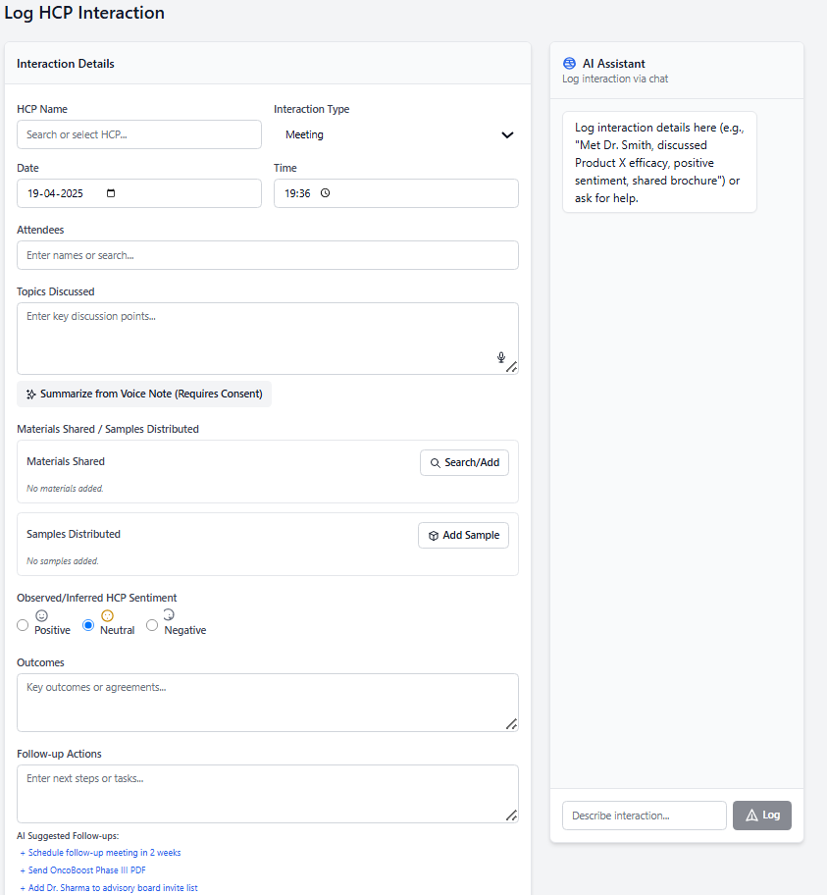`
Video URL: Instructions(Task 1).mp4
or use the URL below: https://drive.google.com/file/d/1njXfNIWa465MfMYwY7YZvY_hGd3fyZX2/view?usp=drive_link

LangGraph AI Agent & Tools:
- Describe the role of the LangGraph agent in managing HCP interactions.
- Define a minimum of five (5) specific "tools" that this LangGraph agent would use for sales-related activities. Two tools must be:
  - Log Interaction: Detail how this tool captures interaction data (potentially using the LLM for summarization, entity extraction, etc.).
  - Edit Interaction: How this tool allows modification of logged data.

Output Deliverables

1. GitHub Submission
- Upload your frontend and backend code in one GitHub repository.
- Add a clear README.md explaining your project and how to run it.
- Share the GitHub repository link using the submission link at the end of this document.
2. Video Recording (10–15 minutes)
In your video, include:
- A walkthrough of your frontend (show how it works).
- A demo of all 5 LangGraph tools working properly.
- A simple explanation of your code and how your project is structured.
- A brief summary of what you understood from the task.
📤 Submission Link
Submit both files separately using this Google Form:
https://forms.gle/XdvLNBJkbdVDGADM8

